This week, I managed to put almost everything together and have a working prototype of my imagination of this project. To refresh your mind, my project was about having a dashboard of weather features that visualizes a bar chart that represents the average of that certain feature in the weather station in different years. We have a year controller that controls the input year. Based on the input of the user, the corresponding data would be retrieved and visualized. Implementing the interaction in this project was the challenging part (multiple years and multiple stations) and I used multiple tags to overcome this issue. The following snapshots show the dashboard for two different stations in the year 2020.

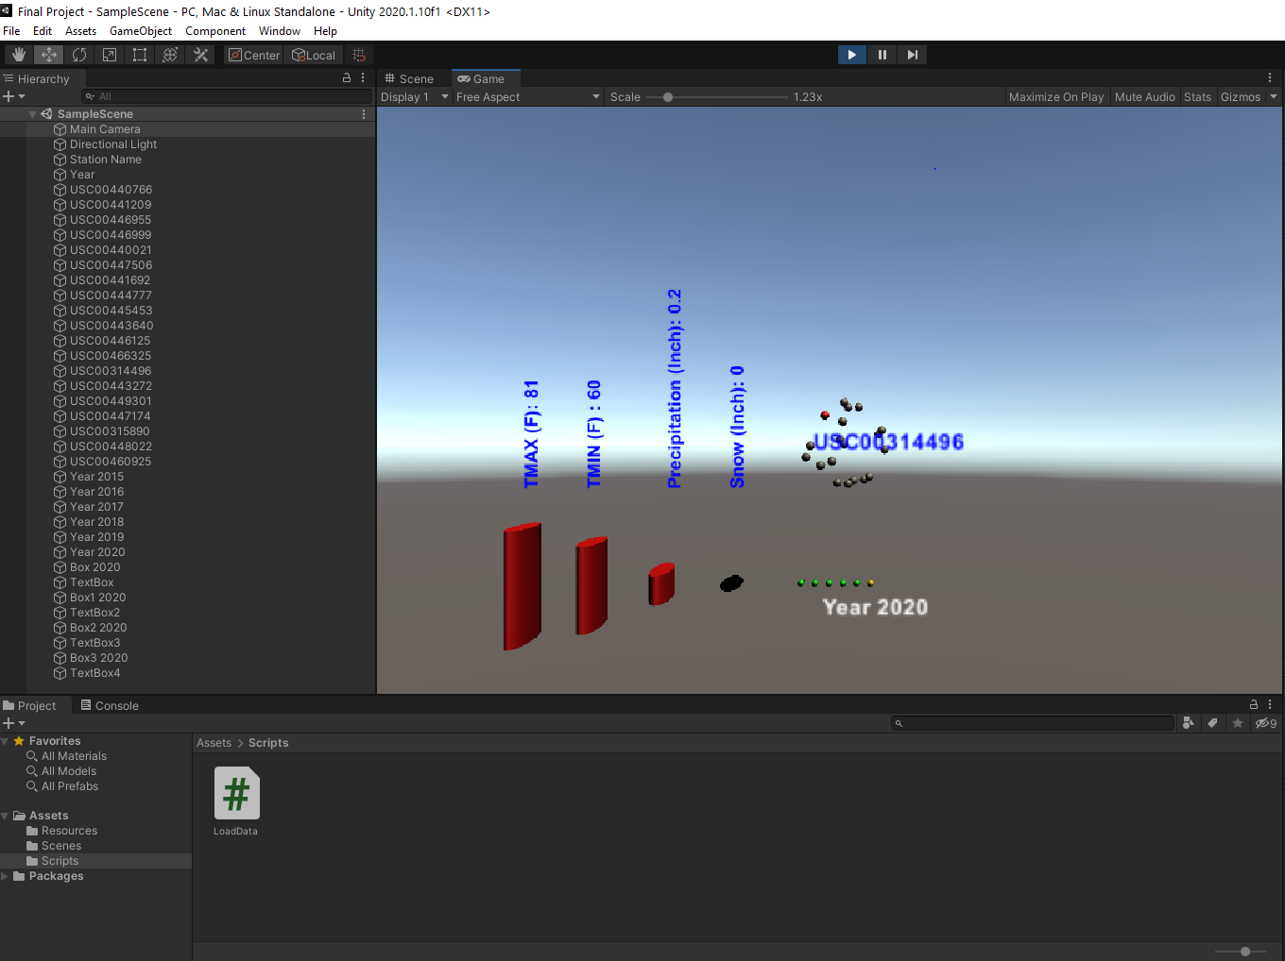

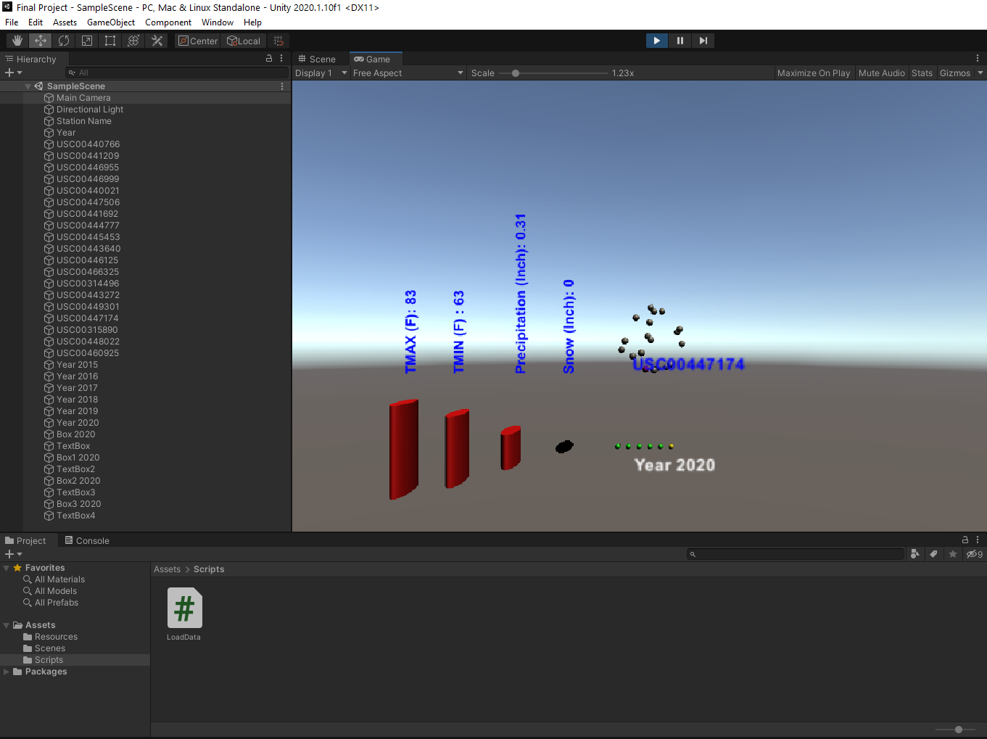

As you can notice, the values rendered and the size of the boxers are different for each station, which is the goal actually.

One other thing to mention is that in this project, besides implementing interaction, positioning the elements in the space was also really challenging for me as the dashboard was somehow complicated.

To Do:

The only missing part is that I only implemented this for the year 2020. So I need to expand the implementation for the other years in the next week and that would conclude my project.